Software specification

Front End

ABOUT VISUAL BASIC

Visual basic evolved from BASIC. Professor John Kemeny and Thomas Kurtz of DARTMOUTH COLLEGE developed visual basic in mid 1960's for writing simple program. The traditional application development process can be broken into three distinct steps: Writing, compiling, and testing code. Unlike traditional languages, visual basic uses an interactive approach to development, blurring the distinction between the three steps.

With most languages if we make a mistake in writing code, the compiler catches the error
When we start to compile our application. We must then find and fix the error and begin the compile cycle again, repeating the process for each error found. Visual basic interprets the code as the user enters it, catching and highlighting mist syntax or spelling errors on the fly. It's almost like having an expert watching over programmer's shoulder as he enter the code The wide spread use of basic with various types of computer and led to many enhancement to the language.
we have used visual basic 6.0 for designing the front end of the software. Visual Basic forms are used to provide the interface to the Railway Enquiry System and Database Maintaining System. The Visual Basic Enterprise Edition contains all of the features included with the Visual Basic Professional Edition and the Visual Basic Learning Edition. In addition, it contains the following features, available in the Enterprise Edition only.

The "Visual" part refers to the method used to create the graphical user interface (GUI). Rather than writing numerous lines of code to describe the appearance and location of interface elements, you simply add pre built objects into place on screen. If you've ever used a drawing program such as Paint, you already have most of the skills necessary to create an effective user interface.
The "Basic" part refers to the BASIC (Beginners All-Purpose Symbolic Instruction Code) language, a language used by more programmers than any other language in the history of computing. Visual Basic has evolved from the original BASIC language and now contains several hundred statements, functions, and keywords, many of which relate directly to the Windows GUI. Beginners can create useful applications by learning just a few of the keywords, yet the power of the language allows professionals to accomplish anything that can be accomplished using any other Windows programming language.
Whether our goal is to create a small utility for yourself or your work group, a large enterprise-wide system, or even distributed applications spanning the globe via the Internet, Visual Basic has the tools that we need.
- Data access features allow you to create databases, front-end applications, and scalable server-side components for most popular database formats, including Microsoft SQL Server and other enterprise-level databases.
- ActiveX™ technologies allow you to use the functionality provided by other applications, such as Microsoft Word Processor, Microsoft Excel
Spreadsheet, and other Windows applications. You can even automate applications and objects created using the Professional or Enterprise editions of Visual Basic.
- Internet capabilities make it easy to provide access to documents and applications across the Internet or Intranet from within your application.

Visual Basic Editions
Visual Basic is available in three editions, each geared to meet a specific set of development requirements. The features available to you depend on which product you have purchased.
Visual Basic Enterprise Edition Features
The Enterprise edition allows professionals to create robust distributed applications in a team setting. It includes all the features of the Professional edition, plus Back Office tools such as SQL Server, Microsoft Transaction Server, Internet Information Server, Visual SourceSafe, SNA Server, and more. Printed documentation provided with the Enterprise edition includes the Visual Studio Enterprise Features book plus Microsoft Developer Network CD’s containing full online documentation.

Visual Basic Professional Edition
The Professional edition provides computer professionals with a full-featured set of tools for developing solutions for others. It includes all the features of the Learning edition, plus additional ActiveX controls, the Internet Information Server Application Designer, Integrated Data Tools and Data Environment, Active Data Objects, and the Dynamic HTML Page Designer. Documentation provided with the Professional edition includes the Visual Studio Professional Features book plus Microsoft Developer Network CD’s containing full online documentation.

Visual Basic Learning Edition
The Visual Basic Learning edition allows programmers to easily create powerful applications for Microsoft Windows and Windows NT®. It includes all intrinsic controls, plus grid, tab, and data-bound controls. Documentation provided with this edition includes

Learn VB Now (a multimedia CD-ROM title), plus Microsoft Developer Network CDs containing full online documentation

Some features of Visual Basic 6.0

- Faster compiler.
- New ActiveX data control object.
- Allows database integration with wide variety of applications.
- New data report designer
- New package & development wizard
- Additional internet capabilities

Back End
We have used “Microsoft Access” for handling the back end of the software Microsoft access is one such package that has increasingly gained acceptance as a DBMS starting with small database feature, one can create complex data-handling.

The Microsoft Access:
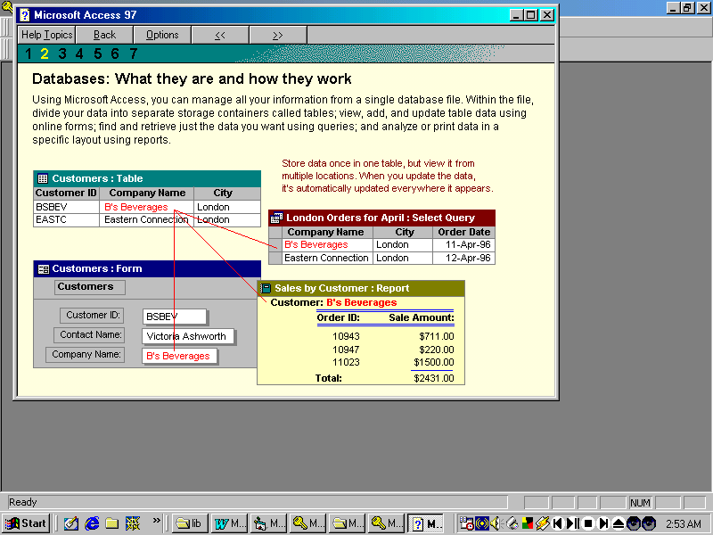
MS Access is a powerful multi-user DBMS developed by Microsoft Corp. It can be used to store and manipulating large amount of information and repetitive tasks, such as maintaining inventory and generating invoices. By using MS Access , one can develop easy to use data input forms. One can process your data and create meaningful reports.
Data in MS Access is organized in the form of tables. Within a table, records are according to a common reference value, known as the primary key or the key field. The value in the key field is different for every record and thus helps uniquely identifying records . a combination of two or more fields can also be used as the primary key . such a combination is called a composite key .
Database in MS Access have a default extension of mdb. MS Access also maintains index files for tables an index is an internal table of values that MS Access maintains to store the order of records. Index objects thus provide efficient access to data. Database Indexes work just like book indexes . when we want to find to find a particular topic in a book , we turn to the index to lookup the page number. Then we turn to relevant page.

Microsoft Access !!features!!

- To store our data, create one table for each type of information we track. To bring the data from multiple tables together in a query, form, or report, we define relationships between the tables.
- To find and retrieve just the data that meets conditions we specify, including data from multiple tables, create a query. A query can also update or delete multiple records at the same time, and perform built-in or custom calculations on our data.
- To easily view, enter, and change data directly in a table, create a form. When you open a form, Microsoft Access retrieves the data from one or more tables and displays it on screen using the layout you chose in the Form Wizard or using a layout that you created from scratch.
- To analyze your data or present it a certain way in print, create a report. For example, you might print one report that groups data and calculates totals, and another report with different data formatted for printing mailing labels.
- To work with all the objects in a Microsoft Access database , use the database window.

Accessing Data

ADO Data Control:-
ADO is designed as an easy-to-use application level interface to Microsoft's newest and most powerful data access paradigm, OLE DB. OLE DB provides high-performance access to any data source, including relational and non-relational databases, email and file systems, text and graphics, custom business objects, and more. ADO is implemented for minimal network traffic in key Internet scenarios, and a minimal number of layers between the front-end and data source — all to provide a lightweight, high-performance interface. ADO is called using a familiar metaphor — the OLE Automation interface. And ADO uses conventions and features similar to DAO and RDO, with simplified semantics that make it easy to learn.

Recordset Object !!ADO!!
A Recordset object represents the entire set of records from a base table or the results of an executed command. At any time, the Recordset object refers to only a single record within the set as the current record.

Remarks:-
We use Recordset objects to manipulate data from a provider. When we use ADO, we manipulate data almost entirely using Recordset objects. All Recordset objects are constructed using records (rows) and fields (columns). Depending on the functionality supported by the provider, some Recordset methods or properties may not be available.
ADOR.Recordset and ADODB.Recordset are ProgIDs that we can use to create a Recordset object. The Recordset objects that result behave identically, regardless of the ProgID. The ADOR.Recordset is installed with Microsoft® Internet Explorer; the ADODB.Recordset is installed with ADO. The behavior of a Recordset object is affected by its environment (that is, client, server, Internet Explorer, and so on). Differences are noted in the Help topics for properties, methods, and events.
There are four different cursor types defined in ADO:
- Dynamic cursor—allows we to view additions, changes, and deletions by other users, and allows all types of movement through the Recordset that don't rely on bookmarks; allows bookmarks if the provider supports them.

- Keyset cursor—behaves like a dynamic cursor, except that it prevents we from seeing records that other users add, and prevents access to records that other users delete. Data changes by other users will still be visible. It always supports bookmarks and therefore allows all types of movement through the Recordset.
- Static cursor—provides a static copy of a set of records for we to use to find data or generate reports; always allows bookmarks and therefore allows all types of movement through the Recordset. Additions, changes, or deletions by other users will not be visible. This is the only type of cursor allowed when we open a client-side (ADOR) Recordset object.
- Forward-only cursor—behaves identically to a dynamic cursor except that it allows we to scroll only forward through records. This improves performance in situations where we need to make only a single pass through a Recordset
Set the CursorType property prior to opening the Recordset to choose the cursor type, or pass a CursorType argument with the Open method. Some providers don’t support all cursor types. Check the documentation for the provider. If we don't specify a cursor type, ADO opens a forward-only cursor by default.
When used with some providers (such as the Microsoft ODBC Provider for OLE DB in conjunction with Microsoft SQL Server), we can create Recordset objects independently of a previously defined Connection object by passing a connection string with the Open method. ADO still creates a Connection object, but it doesn't assign that object to an object variable. However, if we are opening multiple Recordset objects over the same connection, we should explicitly create and open a Connection object; this assigns the Connection object to an object variable. If we do not use this object variable when opening your Recordset objects, ADO creates a new Connection object for each new Recordset, even if we pass the same connection string.
We can create as many Recordset objects as needed.
When we open a Recordset, the current record is positioned to the first record (if any) and the BOF and EOF properties are set to False. If there are no records, the BOF and EOF property settings are True.
We can use the MoveFirst, MoveLast, MoveNext, and MovePrevious methods, as well as the Move method, and the AbsolutePosition, AbsolutePage, and Filter properties to reposition the current record, assuming the provider Supports the relevant functionality. Forward-only Recordset objects support only the

MoveNext method. When we use the Move methods to visit each record (or enumerate the Recordset), we can use the BOF and EOF properties to see if we've moved beyond the beginning or end of the Recordset.
Recordset objects can support two types of updating: immediate and batched. In immediate updating, all changes to data are written immediately to the underlying data source once we call the Update method. We can also pass arrays of values as parameters with the AddNew and Update methods and simultaneously update several fields in a record.
If a provider supports batch updating, we can have the provider cache changes to more than one record and then transmit them in a single call to the database with the UpdateBatch method. This applies to changes made with the AddNew, Update, and Delete methods. After we call the UpdateBatch method, we can use the Status property to check for any data conflicts in order to resolve them.

